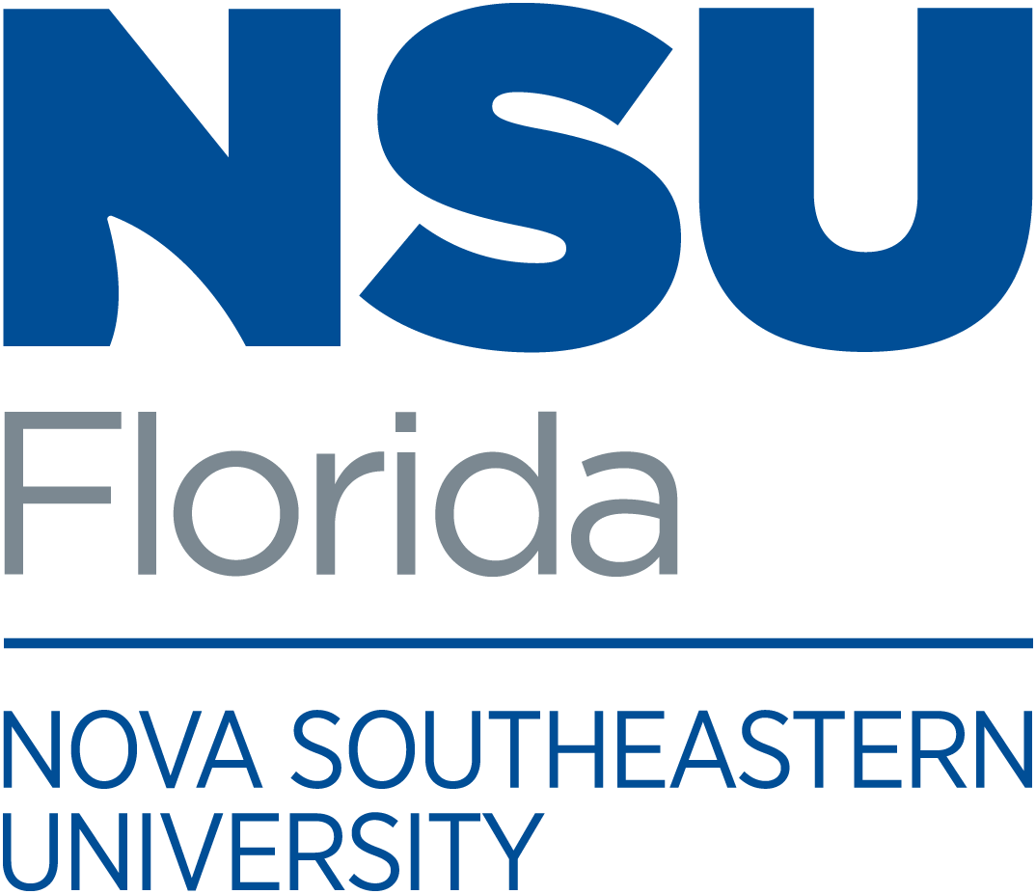

{Event Name}
{Event Date}

PHOTOGRAPHY AND/OR
VIDEOTAPING IN PROGRESS

By entering these premises, you understand that you may be
photographed, filmed, or videotaped and you hereby give
Nova Southeastern University the unqualified right
to take pictures and/or recordings of you and grant the
perpetual right to use your likeness, image,
photo (collectively, “image”), without compensation, for broadcast
or exhibition in any medium and to put the finished pictures/recordings
to any legitimate use without limitation or reservation.
You hereby waive, release and forever discharge
Nova Southeastern University from and against
any and all claims or actions arising out of or
resulting from any use of your image.

Nova Southeastern University shall not be obligated to use,
and may elect not to use, your image.

