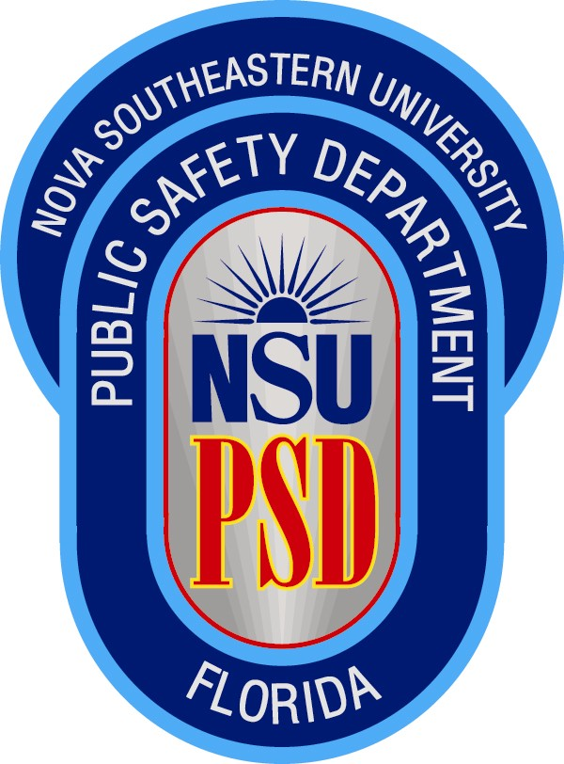


Van Driver Training

Mandatory Training
Nova Southeastern University policy mandates that all personnel/staff/students who either are required to, or wish to use, a NSU van, must first successfully complete the Van Driver Training course provided by NSU Public Safety.

Contact Info
Prior to contacting Public Safety to receive the training, the supervisor/professor/advisor etc., of the person needing training must first contact Director of Risk Management, Elizabeth Guimaraes, at (954) 262-5271, to determine eligibility to drive a NSU Van.

After receiving approval from Elizabeth Guimaraes, an appointment can then be made with Aleksey Loshkin, in Public Safety-Safety Compliance, to receive the training. He can be reached at (954) 262-8989, or at loshkin@nsu.nova.edu.

User Friendly Scheduling
In order to better to serve you, we have adapted the program to be available most everyday of the week, during daytime hours, instead of just once a month during the evening. This flexibility allows students and staff needing the Van Driver Training certification, the ability to pick a date and time more convenient for their schedule.

Updated Training Aids
The NSU Public Safety Department is proud to announce that we have recently updated our Van Driver Training course to the most current version available, Coaching The Van Driver II, which is offered by FLI Learning Systems, Inc.

Certification
Upon satisfactorily passing the Van Driver II Training, the person will receive a certificate of completion as well as an identification card, which is used to sign out a NSU van from the Physical Plant.

