“Privileged” Label for Attorney Client Emails

All NSU College of Law faculty and staff should use the “privileged” label to tag any email communications in their NSU-issued email account that are subject to legal privilege. This label will be used to protect client-attorney privilege by excluding emails labeled as privileged from digital investigation requests.

Below are instructions for how to assign the “privileged” label to new emails for Outlook on the web, your desktop application, or your mobile phone app. The instructions are followed by a frequently asked questions (FAQ) section at the end.

Outlook Web Access (OWA) - SharkMail

Step 1: Log in to Outlook Web Access (OWA) at office365.nova.edu.

Step 2: Select the “New Message” icon on the left side of your menu bar (please see the corresponding numbered steps indicated in the image below for help locating the icons).

Step 3: Select “Sensitivity” button.

Step 4: Choose “Privileged” if your email is subject to legal privilege.

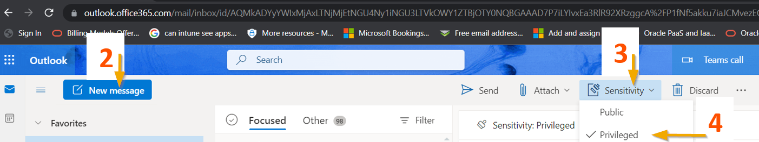

Once the “Privileged” label is selected you will notice the email tip is added to your message, as shown in the image below:

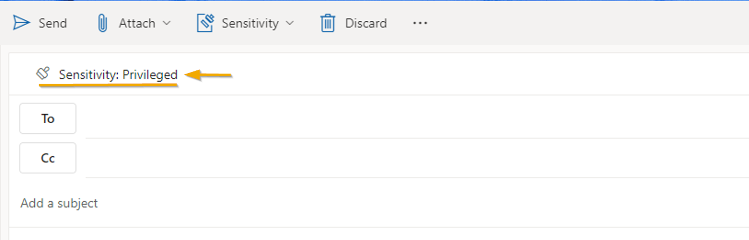

Outlook for Desktop Clients (PC or Mac)

Step 1: Launch the Outlook desktop application.

Step 2: Select “New Email” on the left side of the menu bar.

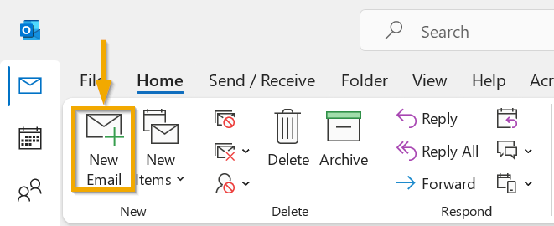

Step 3: In the new message window, select “Sensitivity” from the right side of the menu bar (please see the corresponding numbered steps indicated in the image below for help locating the icons).

Step 4: Choose “Privileged” if your email is subject to legal privilege. Once the label is selected you will see the “Privileged” email tip added to your message (highlighted with the yellow box in the image below):

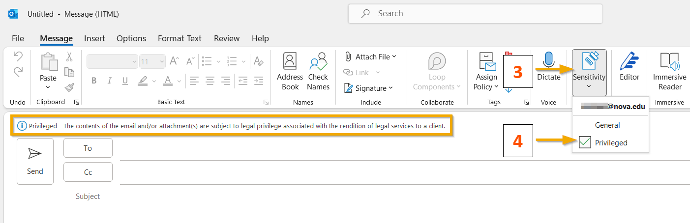
3
4

Outlook Mobile Client (iPhone and Android devices)

Step 1: On the new message compose window select the dots (…) on the lower right corner to edit the message.

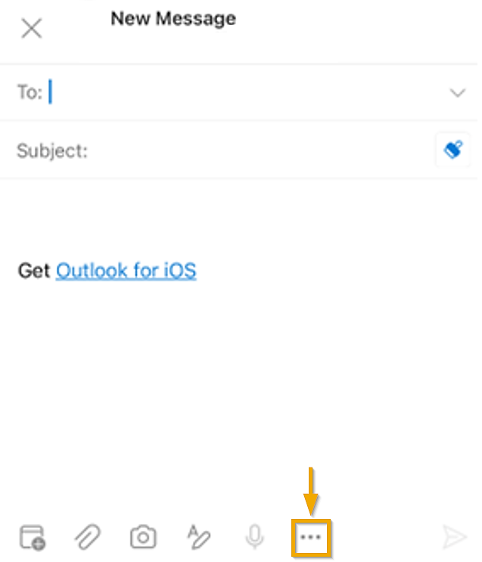

Step 2: Select “Edit Sensitivity”

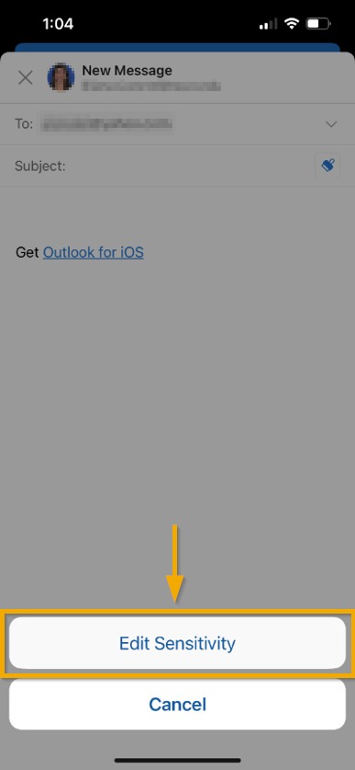

Step 3: Choose “Privileged” if your email is subject to legal privilege.

Frequently Asked Questions (FAQ)

- How can I see what each of the labels mean?
If you hover your mouse over the selection, you will see the definition of the label:

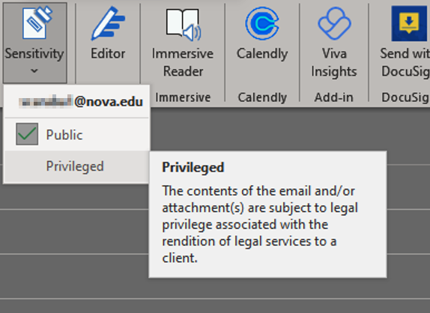

- How do I mark emails that I receive or have received in the past as privileged?
If you have emails that are subject to attorney-client privilege in your inbox, please follow these steps to ensure that the emails are protected:

Step 1: In your email application, right-click on your Inbox then select “Create New Subfolder.”

Step 2: Enter Privileged as the folder name.

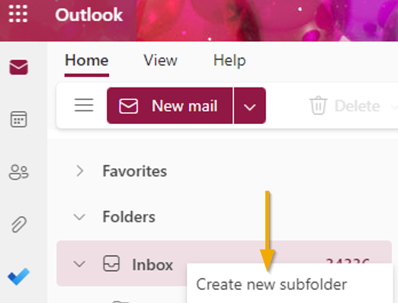

Step 3: You can click and drag any emails in your inbox to this folder if the communication is subject to legal privilege. It will be automatically marked as privileged, as seen below:

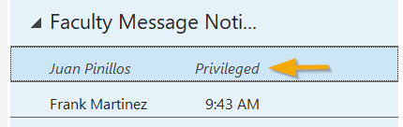

- By mistake I selected the Privileged label for one of my messages that are not protected by client-attorney privilege. How do I change the label to General?
When you change the label back to “general,” you will notice a pop with three options to select. You must select a justification before the label can be changed back to general.

