The performance review will be ready for acknowledgment when the review is in the “Employee & Manager Sign off” step. The employee MUST acknowledge first, as the manager’s acknowledgement sends the review to a Complete Status.
Employee Acknowledgment
After the “Manager and Employee Meet and Review” step is complete the review will be available for the employee to sign off.
- Click on your review.
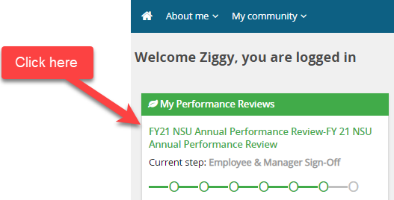

- Click on Next steps to take you to the sign off page.
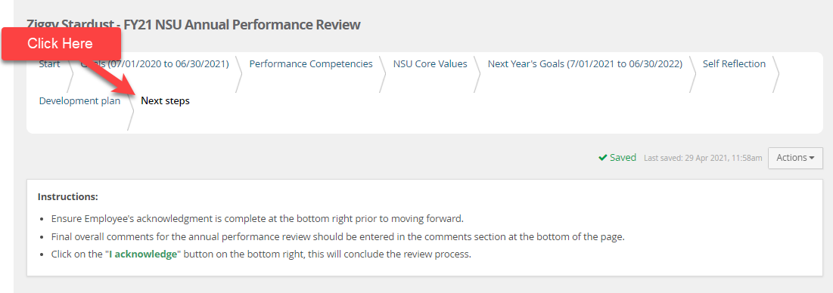

- Scroll down and you will see a text box to enter any final comments.
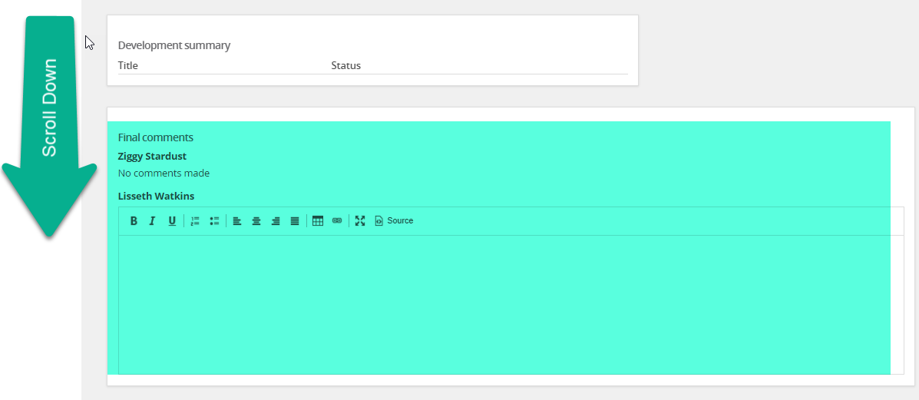
- Scroll back up, you will then see on the right- hand side, an “I acknowledge” button. Once you click the button, a notification will be sent to your supervisor so that they can acknowledge. Their acknowledgement will send the review to the “Review Complete” step, finalizing your review.
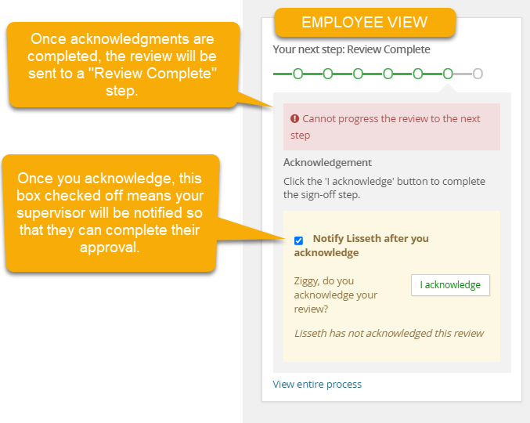

- No further action is needed on your end.

Manager Acknowledgment
After employee acknowledges their review, managers will receive notification of the acknowledgment so that they may act. An employee’s acknowledgment MUST be done prior to the manager’s acknowledgment.

- Notification email is received.
- On your NSU Careers Dashboard under Team Performance Reviews, you will see an “Action Required” notification click on show me
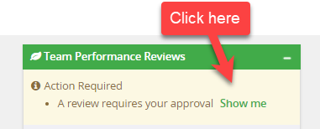
- You will see reviews in “Pending Approval” click on open review
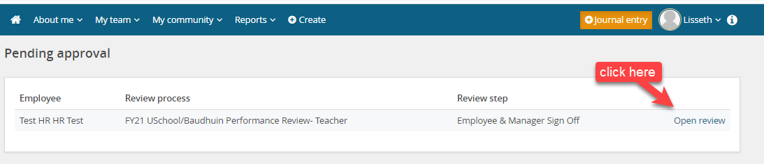
- Review will open Click on “Next steps” to take you to the sign off page.
- Scroll Down and you will see a text box to enter any final comments. You will also see any comments left by the employee.

- Scroll back up, you will then see on the right- hand side, an “I acknowledge” button. Ensure that your employee’s acknowledgement is complete prior to clicking the “I acknowledge” button.
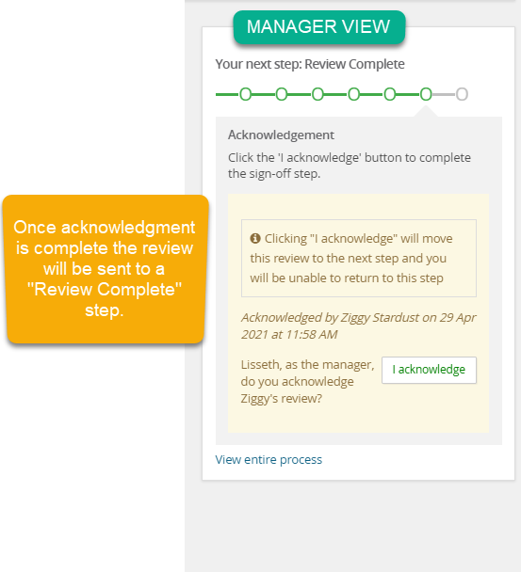
- The review will not be sent to the “Review Complete” step. No further action needed.

